|  |  |
| --- | --- |
|  | Student Name _______________________    **Eastern Goldfields College**  Mathematics 2018  Test 4 (U2 T1) – Calculator Free1 |
|  | **Total Marks: 26 marks** |

**Time allowed: 20 minutes**

**No calculator or notes permitted for this section.**

***Answer all of the following questions. Show all working to obtain full marks.***

**Question 1** **(5 marks: 1, 1, 1, 1, 1)**

Using the **four** classifications listed below, classify each of the following variables and identify the best way to display them.

**Four** Classifications are:

* Categorical and nominal
* Categorical and ordinal
* Numerical and discrete
* Numerical and continuous

|  |  |  |
| --- | --- | --- |
|  | **Data Classification** | **Best Way To Data Display** |
| Gender |  |  |
| Number of Children |  |  |
| Finishing position in a 100 m race |  |  |
| Height |  |  |
| Height to the nearest cm |  |  |

**Question 2** **(7 marks: 1, 2 , 2, 2)**

Solve the following equations:



$2x-6 =14$

$3\left(6-2x\right)=28$

$\frac{3x}{10} = \frac{2}{5}$

$\frac{ 5}{x} =40$

**Question 3** **(6 marks: 2, 4)**

(a) The mean height of a sports team is 182 cm. One of the players who is 172 cm tall leaves the team. Will the mean height increase, decrease or remain the same. Justify your answer.

(b) The whole numbers below are arranged in **ascending** order and have a mean of 6.

1, 3, , 6, 7, , 9, 10

Determine **all** the possible values for  and .

**Question 4**  **(4 marks: 1, 2, 1)**

A rectangular field is $x$ metres wide. The length is 130m longer than it’s width. The perimeter of the field is 520 metres.

1. Write an equation in terms of $x$ for the perimeter of the field.
2. Use **your** equation to solve for $x$.
3. What are the **dimensions** of the field.

**Question 5** **(4 marks)**

Paula had some marbles and Stephen had 11 less than Paula. Together they had a total of 61 marbles. Write an equation to represent this and show full algebraic working to determine how many marbles Stephen had.

**End of Non-Calculator Section**

|  |  |
| --- | --- |
|  | Student Name _____________________    **Eastern Goldfields College**  Mathematics 2018  Test 4 (U2 T1) – Calculator Assumed1 |
|  | **Total Marks: 32 marks** |

**Time allowed: 35 minutes**

**Calculator and 1 x double sided A4 notes permitted for this section.**

***Answer all of the following questions. Show all working to obtain full marks.***

**Question 1** **(5 marks: 2, 2, 1)**

Jeremy sells sausages in bread outside Bunnings on Sundays. The number of sales each day over 30 Sundays was recorded as follows:

66 64 28 93 47 110 53 68 117 43

72 68 84 103 59 82 78 61 104 79

51 63 112 81 79 94 42 57 83 100

1. Draw a stem-and-leaf plot to represent this data
2. On what percentage of days did Jeremy have more than 50 sales?
3. One day Jeremy only had 28 sales. Give one possible reason for this in relation to the scenario.

**Question 2** **(12 marks: 3, 1, 2, 2, 2, 2)**

The birth weights, in kilograms, of **12 baby girls** are listed in ascending order below:

2.95, 3.00, 3.03, 3.06, 3.07, 3.10, 3.15, 3.25, 3.29, 3.41, 3.45, 3.49

(a) For these 12 weights, determine

(i) the mean

(ii) the median

(b) Briefly explain why the mode is not a suitable measure for indicating central location for this data.

The histogram below shows the birth weights of **16 baby boys**.

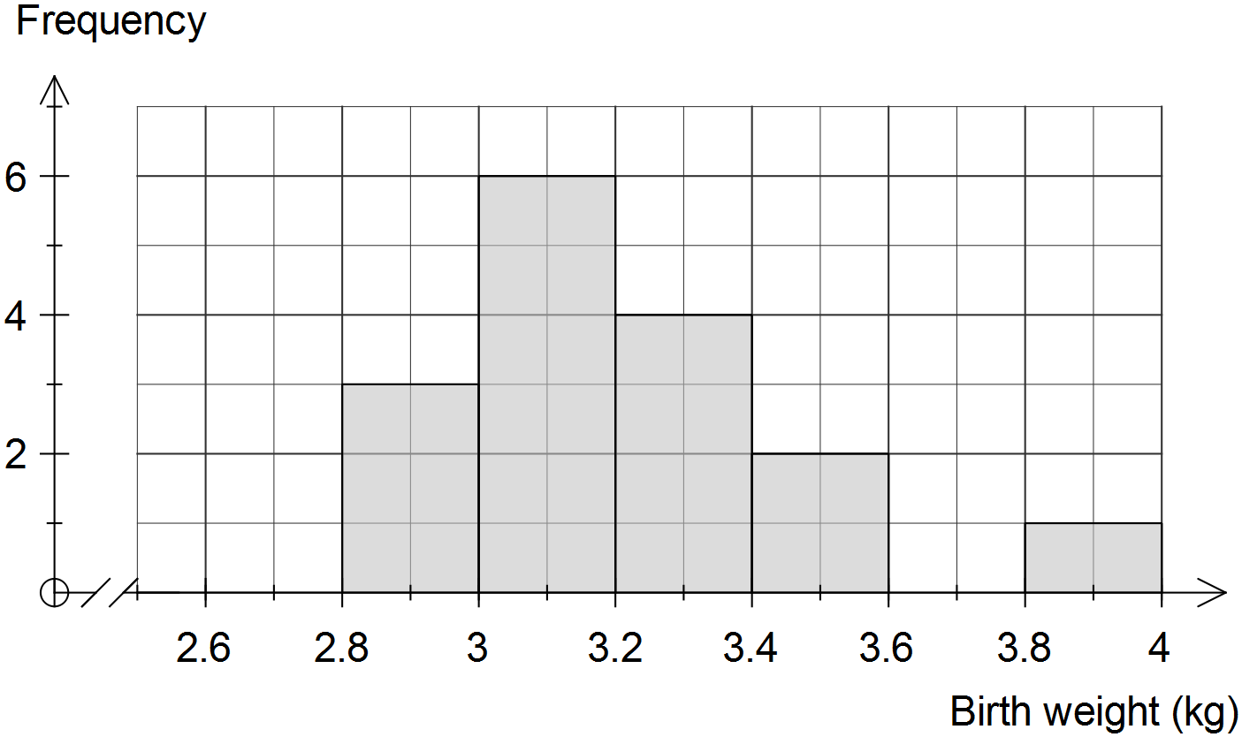

(c) Describe the distribution of the weights of the 16 baby boys.

(d) Use the information on the previous page to complete the frequency table below for the **combined weights** **of all** **28 babies**.

|  |  |
| --- | --- |
| Weight (kg) | Frequency |
|  |  |
|  | 5 |
|  |  |
|  |  |
|  |  |
|  |  |
|  |  |

(e) Estimate the mean weight of all 28 babies using the frequency table.

(f) Use the frequency table in (d) to construct a frequency histogram on the axes below.

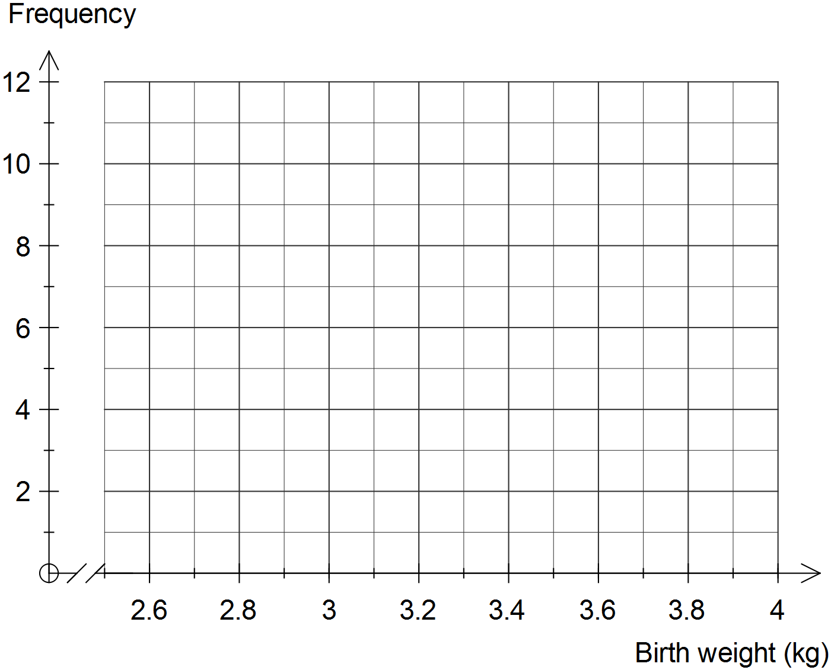

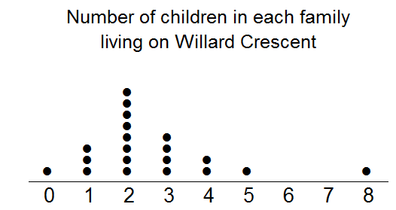**Question 3** **(8 marks: 1, 2, 1, 2, 2)**

This dot plot shows the number of children in each family living on Willard Crescent.

1. How many families live on Willard Crescent?
2. Calculate the mean number of children per family.
3. The family with 8 children is an outlier. Without re-calculating the mean, how is the mean affected if this outlier is removed from the data set?

1. Give two reasons why the mean is not a good measure of centre for this data.

1. An extra family moved into Willard Crescent, increasing the mean number of children to 3. Considering all the original data (including the outlier), how many children did the new family have?

**Question 4** **(2 marks)**

The mean of seven scores is 53. If six of the scores were 60, 50, 37, 60, 55 and 32, find the seventh score.

**Question 5 [5 marks]**

Two classes, class A and class B, sit the same test and the combined mean is 72%. Class A has 50 students in it and the class mean is 69%. Class B has a class mean of 78%. Determine the total number of students for class B. Ensure you show full algebraic working.

**End of Calculator Section**